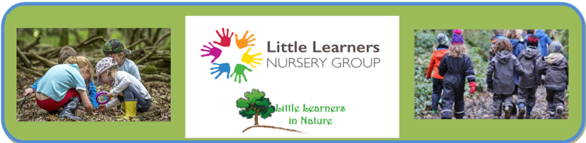

Clothing Information
It is recommended that your child have a full set of spare clothes whilst attending the Nature Area. It would be preferred if these clothes were kept in a named drawstring bag. As the children are likely to need to get changed more often than at a typical nursery, please make sure that absolutely everything is named to avoid losses.
Shoes
Your child will need an indoor pair of shoes (such as slippers) and an outdoor pair of shoes. For the outdoors, it is recommended that your child have some walking boots or wellington boots with warm socks.
Socks
As water can find its way in from the top of even the tallest wellies we recommend that you include at least three extra pairs of socks in your child’s bag.
Trousers
We would prefer that all children wear long trousers or shorts in the Nature Area rather than anything flowing, ideally out of a quicker drying material rather than wearing jeans. All children should bring waterproof trousers with them in case of adverse weather conditions.
Tops
Layering is key! Your child will need a t shirt, long sleeved top and a jumper in order to stay warm. A waterproof jacket is essential
Gloves
Nothing woolly or precious! We want the children to be as hands-on as possible. Because of this we would prefer if the children have as much use of their hands as possible whilst still being able to keep warm – therefore no mittens please. Similarly, anything particularly fluffy will most likely get ruined quickly - having two pairs of gloves such as these would be ideal! One cotton for drier weather, and a pair of ski gloves for keeping water away from cold hands – link below.
https://tinyurl.com/ycp236tk

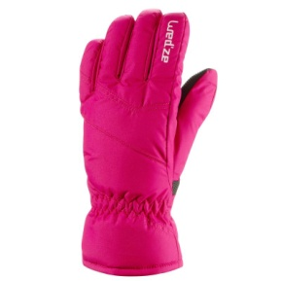
Hat
A warm hat goes a long way in cold weather; scarves are optional but could come a slight annoyance when dangling. Similarly, children will need a sun hat when the weather begins to warm.
Water Bottle
Children will need their own water bottle that they will bring between the outdoor and indoor areas.

